Project Development Phase
Model Performance Test

Date | 03 Oct 2026
Team ID | Team 12
Project Name | Streamlining IT Procurement: Automating Standard Laptop Orders with Flow Designer
Maximum Marks

Model Performance Testing:
Project team shall fill the following information in model performance testing template.
S.No. | Parameter | Values | Screenshot
 | Model Summary | Not Applicable (N/A) – The project uses Flow Designer-based workflow automation and does not use a machine learning model. | 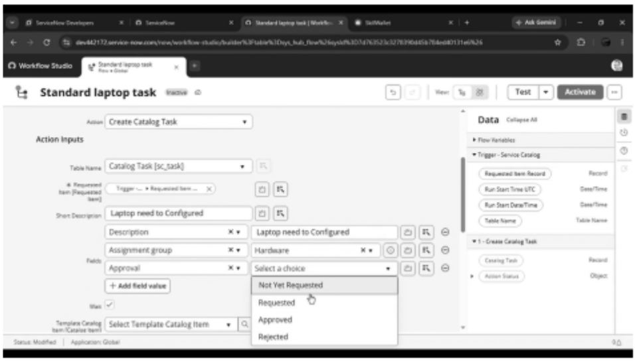
 | Accuracy | raining Accuracy – N/A  Validation Accuracy – N/A  No machine learning model is trained or validated in this project. | 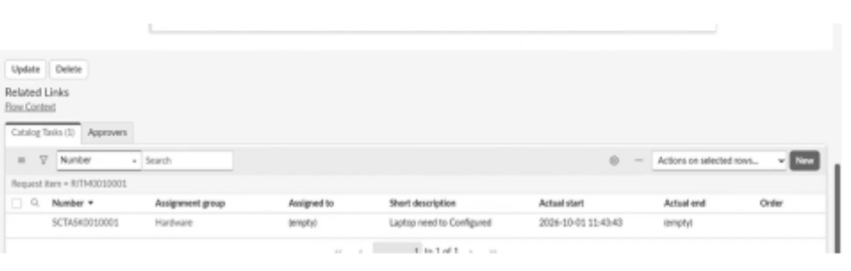
3. | Fine Tunning Result( if Done) | N/A – Fine-tuning is not performed because the project does not use a machine learning model.  Validation Accuracy – N/A | -

